**Name-Prakhar Rathore**

**Reg.No. - 19BCE1793**

**CSE4022 Natural Language Processing**

**Digital Assignment -1**

1. Utilize Python NLTK (Natural Language Tool Kit) Platform and do the following. Install relevant Packages and Libraries

* Explore Brown Corpus and find the size, tokens, categories,

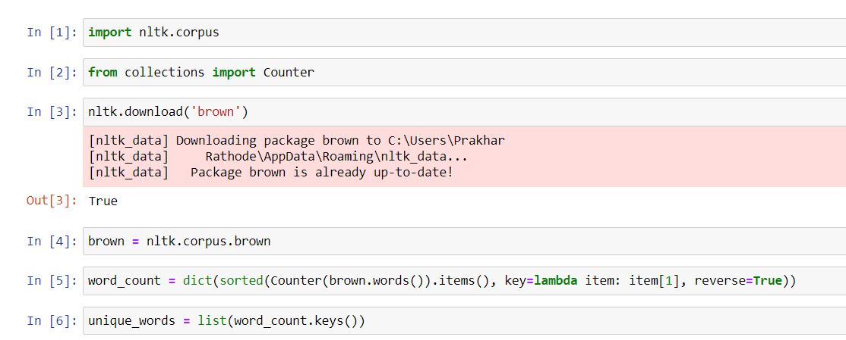

* Find the size of word tokens?

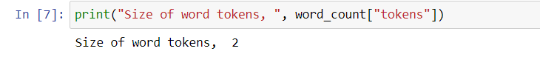

* Find the size of word types?

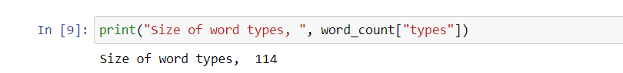

* Find the size of category “government”



* List the most frequent tokens

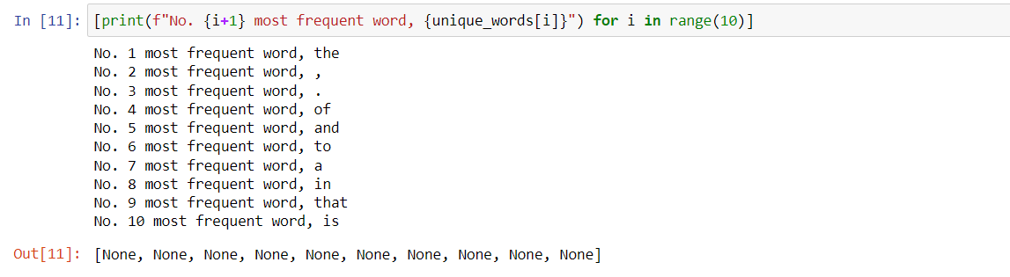

* Count the number of sentences

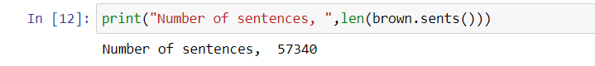

1. Explore the corpora available in NLTK

